

Segment Architecture Overview
Version Number: 1.0
Version Date: <mm/dd/yyyy>

Notes to the Author

[See the FEA Segment Architecture Methodology (FSAM) (http://fsam.gov/) for more guidance and examples.]

Segment Architecture Overview Approval

The undersigned acknowledge that they have reviewed the <Segment Name> Segment Architecture Overview and agree with the information presented within this document. Changes to the Segment Architecture Overview will be coordinated with, and approved by, the undersigned, or their designated representatives.

[List the individuals whose signatures are desired. Examples of such individuals are Business Owner, Solution Architect, Project Manager (if identified), and any appropriate stakeholders. Add additional lines for signature as necessary.]

Signature: |  | Date:
Print Name:
Title:
Role:

Signature: |  | Date:
Print Name:
Title:
Role:

Signature: |  | Date:
Print Name:
Title:
Role:

Revision History

This table records information regarding changes made to the document over time.

Version | Date | Organization/Point of Contact | Description of Changes
1.0 | <mm/dd/yy> | <Organization Identifier / Point-of-Contact Name> | Baseline Version

Table of Contents

1. Introduction 7
1.1 Overview 7
1.2 Background 7
2. Purpose Statement 10
3. Scope 10
4. Mission 11
5. Vision 11
6. Security Overview 12
7. Segment Deliverables 12
8. Segment Stakeholders 12
8.1 Stakeholder and Role Overview 12
8.2 Stakeholder Map 13
9. Governance Framework 13
10. Referenced Documents 15
11. Glossary 15
12. Acronyms 17

List of Figures

Figure 1: Architecture Levels 7
Figure 2: Architecture Artifacts by Level 8
Figure 3: IT Investment Life Cycle 9
Figure 4: Operating Environment Diagram 11
Figure 5: Segment Vision Diagram 12
Figure 6: Segment Governance Framework Organization Structure 14

List of Tables

Table 1: Segment Stakeholders 12
Table 2: Governance Roles and Responsibilities 14
Table 3: Referenced Documents 15
Table 4: Glossary 17
Table 5: List of Acronyms 17

Introduction

Overview
The Segment Architecture deliverables are based on the Federal Enterprise Architecture (FEA) Segment Architecture Methodology (FSAM) which consists of:

- Segment Architecture Overview. This document defines the scope, mission, and other driving factors for the segment. A governance framework may be established.

- Segment Baseline Architecture. This document describes the baseline (i.e. as-is) architecture for the segment.

- Segment Target Architecture. This document describes the target (i.e. to-be) architecture for the segment.

- Segment Architecture Recommendations. This document describes the recommendations for the segment architecture. As part of the recommendations, this document highlights the gap between the baseline and target architecture.

- Segment Architecture Migration Plan. This document describes the approach and steps to migrate from the as-is state to the to-be state, thereby achieving the target architecture.

Background
The Enterprise Architecture is incrementally defined by performing architecture analysis on sections of the enterprise architecture, called segment architectures. Figure 1: Architecture Levels illustrates the architecture levels and their relationship.
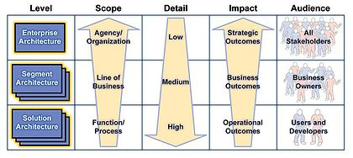
Figure 1: Architecture Levels
Figure 2: Architecture Artifacts by Level illustrates the events that trigger each architecture level and the artifacts developed for each architecture level.
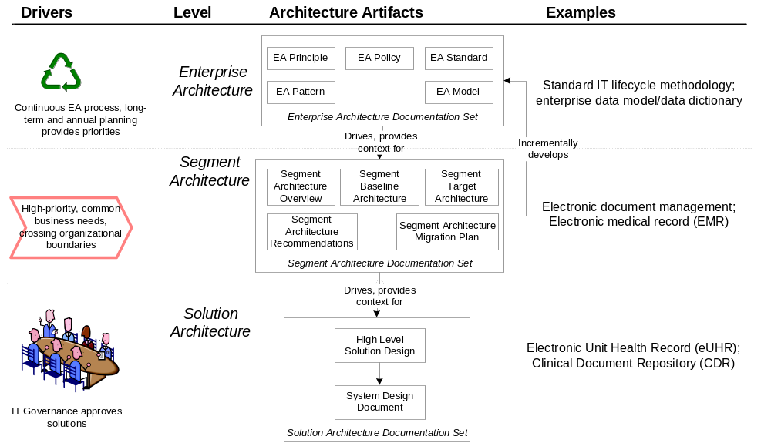
Figure 2: Architecture Artifacts by Level

Figure 3: IT Investment Life Cycle illustrates the segment architecture deliverables in context of the full IT investment lifecycle.
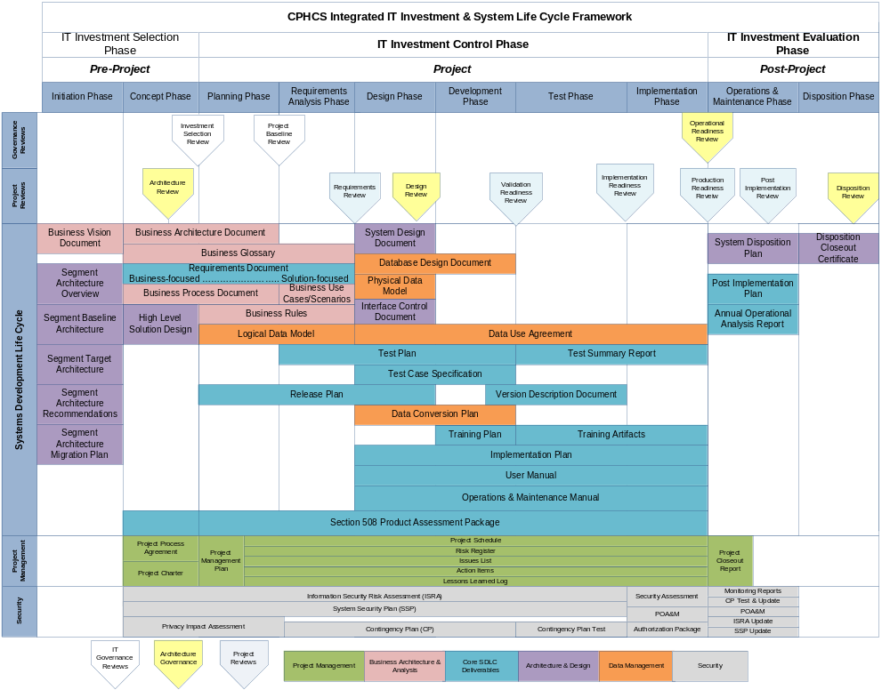
Figure 3: IT Investment Life Cycle

Purpose Statement
The purpose statement serves to communicate to all stakeholders the reason why the segment architecture is being created. For example, the purpose statement could be higher citizen satisfaction, lower costs, more efficient operations, addressing a GAO audit, and/or introducing a new service to citizens. The purpose statement can be a set of principles or detailed listing of objectives and expected areas to consider.
[Include segment purpose statement.]

Scope
Since segments may be extremely broad from a function, process, product, service, and organizational impact standpoint, it is imperative that a clear understanding of the focus for the segment is defined up front. In order to define the segment’s scope and strategic intent, the architect can use this process step to develop a comprehensive understanding of the relevant segment goals and desired outcomes, major strategic improvement opportunities, performance gaps, business mandates and drivers, and key common / mission services delivered to meet principal stakeholders’ needs.

[Briefly describe the scope of the segment]

Figure 4: Operating Environment Diagram depicts the current state of the operating environment provide the scope and context through which the subsequent process steps are bound. The current operating environment diagram depicts any of the in-scope components of the current operating environment (e.g. resources, stakeholders, organizations, processes, activities, etc.) and potentially depicts any of the segment drivers or challenges.
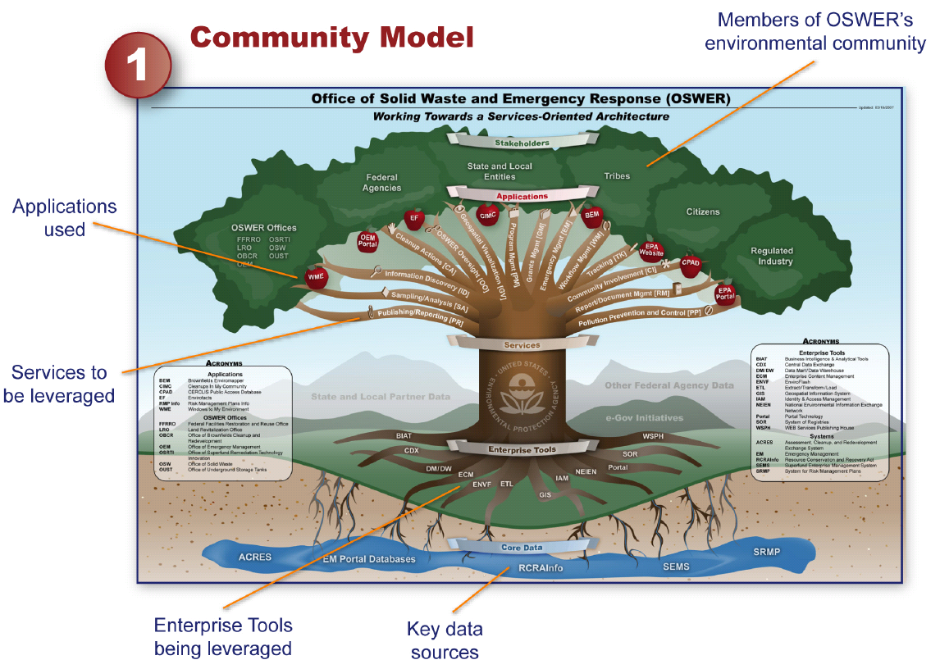
Figure 4: Operating Environment Diagram

Mission
This section includes the mission statement that describes the motivation behind the segment.
[Provide the mission statement.]

Vision
This section describes the current situation in the segment, how the segment will be transformed, and how the transformation will change the situation. This section also describes the benefits of the segment transformation.
[Provide vision]

Figure 5: Segment Vision Diagram depicts the target state vision for the segment.
[This should depict common elements from the current operating environment diagram, but should be modified to show the difference, based on accomplishing the segment vision. It should be easily discernable as to what has changed between the current operating environment diagram and this diagram.]

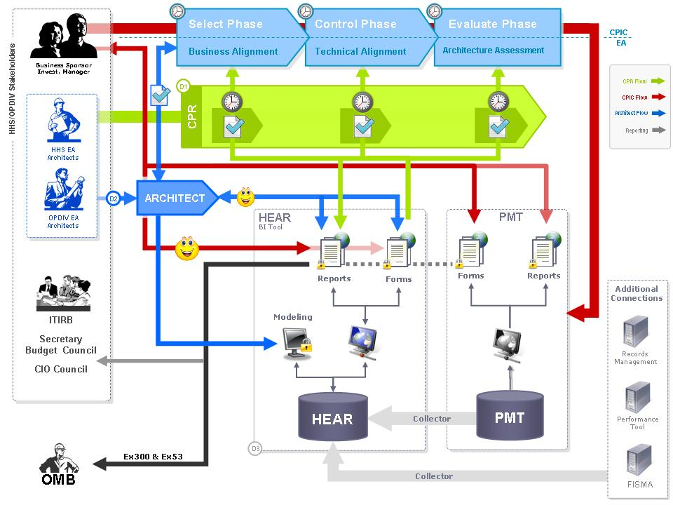
Figure 5: Segment Vision Diagram

Security Overview
The section describes the security and privacy related risks, impacts to the segment, and high-level mitigation strategies.
[Insert risks, impacts, and mitigation strategies]

Segment Deliverables
This section contains a list of segment deliverables agreed to by the segment governance process.
[List of segment deliverables.]

Segment Stakeholders

Stakeholder and Role Overview
Table 1: Segment Stakeholders captures general information about the segment stakeholders.

Stakeholder Name | Role | Belongs To | Contact Phone/Email Address
… |  | …
Table 1: Segment Stakeholders

Stakeholder Map
The stakeholder map identifies the appropriate stakeholders and the relationships between them and the servicing organization. It ensures the inclusion of all relevant perspectives on how to overcome the business challenges identified in the segment purpose statement.

Governance Framework
The purpose of the governance framework is to outline the governing bodies and their decision-making authority in terms of segment architecture activities related to how to deliver the segment mission services, manage business and information requirements, manage technical and services standards, and measure and manage overall mission performance. The framework provides a formalized definition of decision-making roles and responsibilities to facilitate cross-agency governance of segment architecture efforts, issues, etc.

Committee / Role | Overview of Roles and Responsibilities
Executive Steering Council (ESC) | It is designed to provide executive leadership, vision, direction, and fundamental support for the program that is responsible for delivery of the overall segment mission. The ESC sets policy and strategy, secures funding, appoints key personnel to the PMO, approves the ConOps, and makes other decisions as required. The ESC advocates for segment at senior levels of government and among key constituencies and appoints the Segment Executive Sponsor.
Business Owner | Senior executive-level official with decision making authority within an organization for the segment under development.
Executive Sponsor | The executive sponsor should therefore be a senior official with the authority to make decisions within the segment. The executive sponsor serves as champion for the concept of transformation within the segment and acts as a key visionary leader for the core team. Along with the core team, the executive sponsor is responsible for determining the direction and scope of the segment architecture findings and recommendations.
Core Team | This core team is a working level body of individuals, typically at the program manager level within the segment. The core team is an important group as these subject matter experts will guide the development of the segment architecture. The core team may be extended to include other key stakeholders and IT personnel (e.g., security).
Policy Advisory Panel | It is designed to identify policy issues of concern to the segment stakeholder community, analyze them, resolve them when appropriate and provide policy recommendations and advice to segment leadership in order to facilitate resolution of issues that require decisions by higher authority.
Segment Program Management Office (PMO) | The PMO is the operational arm for program activities that are responsible for delivery of the overall segment mission. The PMO is responsible for executing the vision defined by the ESC, strategic planning to support the program, and day-to-day management and operations.
National Priority Implementation Panel | The National Priority Implementation Panel is chartered with facilitating the development and deployment of high-priority mission critical elements of the segment target state vision that are required to address key national priorities. For example, the Department of Justice maintained a National Priority Exchange Panel to facilitate and expedite the development and nation-wide deployment of high-priority information exchanges.
Segment Business Architecture Committee (BAC) | The BAC is designed to guide the development, harmonization, evolution, and implementation of segment core data components and operating processes from a business architecture perspective.
Segment Communications and Outreach | Communications and Outreach is the activity responsible for ensuring that information regarding segment architecture is consistently and effectively presented to key decision makers, agency executives, legislative and elected officials, investors, practitioners, agency representatives, relevant communities of interest (COIs), and the general public.
Segment Technical Architecture Committee (TAC) | The TAC is designed to address technical and structural details associated with segment architecture development and implementation.
Table 2: Governance Roles and Responsibilities
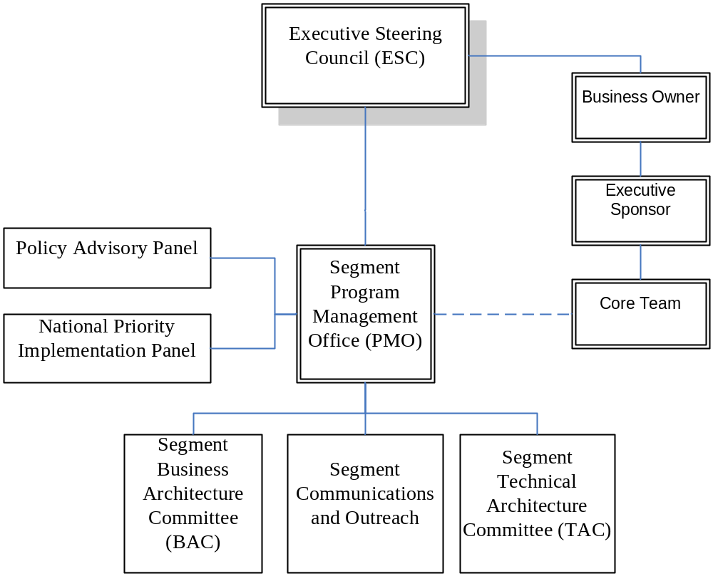
Figure 6: Segment Governance Framework Organization Structure
Note that each governance committee in the segment governance framework should be chartered separately to outline the specific details of the authority, roles, responsibilities and decision making processes applicable to each.

Referenced Documents
Table 3: Referenced Documents lists all documents used to arrive at and/or referenced within this document (e.g., related and/or companion documents, prerequisite documents, relevant technical documentation, etc.).

Document Name | Issuance Date
 | <Month Day, Year>
Table 3: Referenced Documents

Glossary
This section defines the terms used in the document that may be unfamiliar to readers of the document.
Term Name | Definition | Source
Baseline Architecture | Describes the current ("as is") state of the agency in terms of performance, business, data, services, and technology. | FEA
Business Architecture | A functional perspective of the overall agency EA, providing information about the agency's baseline and target architectures. Examples of elements are:  - Agency business processes, aligned to business sub-functions within the FEA BRM  - Internal and external participants (roles) within these business processes  - Linkage between agency business processes and agency-specific performance measurement indicators  - Linkage between business processes to agency service components  - Agency programs, linked to business processes  - Offices and facilities. | FEA
Business Services | Defined by the agency business model, business services include the foundational mechanisms and back-office services used to achieve the purpose of the agency, e.g., inspections and auditing, direct loans, program monitoring, and financial management. | FEA
Conceptual Solution Architecture | The conceptual solution architecture defines the segment systems and services (e.g., business and information exchange) including the supporting technical and service components. | FEA
Core Mission Areas | Unique service areas that define the mission or purpose of the agency. Core mission areas are defined by the agency business model (e.g., tactical defense, air transportation, energy supply, pollution prevention and control, and emergency response). | FEA
Data Model | A data model in software engineering is an abstract model that describes how data is represented and accessed. Data models formally define data objects and relationships among data objects for a domain of interest. | FEA
Enterprise Architecture | A management practice for aligning resources to improve business performance and help agencies better execute their core missions. An EA describes the current and future state of the agency and lays out a plan for transitioning from the current state to the desired future state. | FEA
Performance Architecture | A perspective of the overall agency EA that provides information about the agency's baseline and target architectures. Examples of elements are:  - Agency strategic goals and objectives (as per the agency's Strategic Plan and IRM Plan) and linkage between performance indicators and business processes  - Agency-specific performance measurement indicators aligned to the generic measurement indicators described in the FEA PRM  - Linkage between the agency's strategic goals and investments. | FEA
Segment | Individual elements of the enterprise describing core mission areas and common or shared business services and enterprise services. Segments are defined by the enterprise architecture. | FEA
Segment Architecture | Detailed results-oriented architecture (baseline and target) and a transition strategy for a portion or segment of the enterprise. | FEA
Service | Discrete unit of functionality that can be requested (provided a set of preconditions is met), performs one or more operations (typically applying business rules and accessing a database), and returns a set of results to the requester. Completion of a service always leaves business and data integrity intact. | FEA
Solution Architecture | An architecture for an individual IT system that is part of a segment. A solution architecture is reconciled to the segment architecture above it. | FEA
Stakeholder | A person, group, organization, or system who affects or can be affected by an organization's actions. | FEA
Strengths, Weaknesses, Opportunities, and Threats (SWOT) Analysis | SWOT Analysis is a strategic planning method. A SWOT Analysis is one analysis technique that could be leveraged to identify strategic improvement opportunities. The analysis technique involves identifying the internal and external factors that are favorable and unfavorable to achieving a goal or strategic objective. Some specific factors to be considered include security. A review of the internal security factors may identify some strengths or weaknesses of an agency security processes and/or systems. Additionally, a review of security factors that may in fact be opportunities, but in most cases threats should be exposed early on in the analysis. These security factors may impact the resulting analysis dramatically, based on the type of strength, weakness, opportunity, or threat identified. | FEA FSAM
Target Architecture | Describes the future ("to be") state of the agency in terms of performance, business, data, services, and technology. | FEA
Vision Statement | Summary description of the target business and information management environment to fulfill requirements, address change drivers, and achieve performance improvements. | FEA
Table 4: Glossary

Acronyms
This section provides a list of acronyms and associated literal translations used within the document.
Acronym | Literal Translation
EA | Enterprise Architecture
FEA | Federal Enterprise Architecture
Table 5: List of Acronyms

